HSCI 615 Paper
Sales Force – Case Management
5/12/2019
HSCI 615
HR Sales Force – Case Management
Preliminary Observations
What is the environment of the organization?
Kaiser Permanente Woodland Hills (KPWH) Human Resources Department supports nearly 3,810 employees, not including physicians and 190 department administrators, assistant department administrators, and supervisors (including SVP, CAO, COO, CFO and et al.). KPWH is united by three major entities which are known as Kaiser Permanente Health Plan, Kaiser Permanente Medical Group, and Kaiser Foundation Hospital. As of September 14, 2018, all Kaiser Permanente Medical Centers - Human Resource Departments and Regional Offices have undergone drastic changes in HR IT systems. Each HR Department in Southern California and Northern California adopted an IT program known as Salesforce - Case Management. This is a tool used to create, track, and report cases electronically, such as grievances, complaints, EEO investigations, arbitrations, and legal cases. The work environment of my organization is heavily based on policies, regulation, and consulting.
Problem Description
Defining the problem to be solved and flow chart
The main purpose to implement Sales Force – Case Management system for all HR departments was to have one HR database system to create, track, and report on cases from HR. After millions of dollars were given to create the system and execute training guides nationally for all of the HR workforce, I observed several problems that created inconsistencies and lost productivity, which has caused the company a loss on its return on investment. It has been nearly 9 months since KPWH has implemented Sales Force – Case Management. There has been minor issues that impact day-to-day workflows from all levels such as administrative, consulting, and legal. Therefore, my proposal is to resolve the programming that is absent in the current software to improve the workflow, productivity, and consistency for storing cases or to purchase an entire new system that contains all necessary elements.
Illustration of the Problem System Figure 1. & Figure 2.
To help you understand the process of creating a case, please see figure 1. Figure 1. shows the workflow process of creating a case on Case Management. The area for improvement is the second step – admin creates four types of methods to track and manage one case. The purpose of case management was to move away from paper-based files and be fully integrated with using an electronic tracking system. However, case management currently does not have all the elements HR uses to manage a case. The limitations are programming and reporting, when a consultant hears a grievance, they need to do research on the employee and need a summary checklist of the grievance issue and employee job data (Date of Hire, Pay, Union, Position). This is manually logged on an Excel tracker. Where instead, the employees job data and issue can be automatically generated on case management which would eliminate one of the four methods to log a grievance.
Figure 2. Shows the expanded workflow after a case is logged and once multiple people begin to work on a case. There are multi levels that a case is overseen by, which makes it more difficult to manage because there is four methods of tracking and not everyone communicates updates to the admin. The model below shows me that we are using a well-known IT cloud program, but we need to purchase additional components to fully utilize Sales Force Case Management to its full potential. The area needed is integration with outlook, adobe, Microsoft 365 – Word, Excel, and PPT, Oracle for employee job data, and multi user access.

Figure 2.
Two Different Solutions and Data Requirements
Solution #1
The first solution is to purchase additional programming for the current Sales Force - Case Management system to supplement the missing filters, integration of other systems/programs, and resources. For example, currently the case management system allows Microsoft Outlook emails to be logged on the electronic case, however, attachments in Outlook emails are not supported by the software in order to be saved on the electronic case. So it causes the user to manually save as a PDF any email communication and attachments to a shared drive folder so it can be manually uploaded to case management. However, if we purchased additional software coverage to allow attachments to be uploaded directly from Outlook, then this would save time, money, and reinforce one source of information to manage a case. As shown in the flow chart, the admin manually inputs information for each case on an Excel tracker, if we purchased a reporting component then the data would be automatically generated once a case has been created which would result in eliminating another method of tracking.
Solution #2
The second solution is to buy a different case management system known as Neocase. Neocase transforms HR Shared Service Centers to reduce operational costs by up to 50 percent, enhances employee satisfaction by more than 50 percent, and automates HR processes (Neocase, n.d). The system is integrated, scalable, and flexible to HR processes. The software has additional components that do not need to be altered and are available to use such as case management, business process management, real time dashboards, self-service portals, live chat, knowledge base, and business intelligence document management. Therefore, by purchasing an entire new system that contains all the elements needed for HR cases would be a solution.
Preliminary examination of data/information
The data I would need to assess both solutions is Kaiser Permanente’s case management cases and a trial of Neocase system data. I can assess the efficiency of the KP’s case management program by determining the cost to purchase the software, cost to train the workforce, and the number of cases generated since using the new system. Also, seeing the hours spent creating four tracking methods to create and manage one case to then compare the time it would take to create and track a case on the proposed alternative Neocase system. I can then compare the cost it would be to modify the Sales Force – Case Management System to ultimately have all the components needed to use only one software and eliminate the other three methods to creating a case. Meanwhile, the data available for solution #2 is only a fixed cost to purchase the program and an estimated probability of long-term usage of the software. However, I have limited access to the prices for any system at KP since regional offices handles all transactional purchases and there are multiple layers of approval and confidentiality with systems.

Literature Search and Review
In the following article, “Managing Human Resources in Information Technology: Best Practices of High Performing Supervisors” focused on addressing challenges commonly confronted in the IT work environment. The challenges fall under two categories: Task focused (boundary spanning, performance management, employee involvement, training and development) and Person-focused (relationship building, mentoring, stress management) practices. The article concludes that while leadership practices are effective with other types of professionals, they also are appropriate for IT professionals and can be tailored to unique IT demands. The articles also discusses the correlation of management and the work environment, although it is not specifically regarding HRIS systems this article still applies to the concept of managing the employees as person focused or task focused. The current work flow process is task focus that needs to be improved.
The following article, “Human Resource Information System (HRIS) in the HR Planning and Development in Mid to Large Sized Organizations” discusses the role of Human Resources Management (HRM). Most medium and large scale organizations spend large amounts of money and reserves on HR software, but unfortunately many of the companies utilize the software for only HR administrative purposes rather than for effective and efficient human resources planning. The study explores usage of HRIS systems in medium to large sized organizations and the advantages that derive from the implementation of the same HR planning subfunctions. HRIS outlines the integration between HRM and Information Technology. Results also showed that organizations can record good HR planning efficiency and effectiveness if HRIS aligns with information system strategy and HR strategy (Nagendra and et al, 2014). Organizations need to integrate HRIS functions with other business functions. HRIS needs to offer more intelligent capabilities to increase the effectiveness of HR planning (Nagendra and et al, 2014).
Analytical Techniques

Cost-Benefit Analysis

Since the two proposed solutions require personnel functions, such as HR workforce and shareholders, the programming that will be added to support Human Resources Information System – Case Management requires an evaluation of the cost and benefit comparison to determine which solution is best to use. The cost benefit analysis below provides a framework and system for understanding what solution best reflects the needs of the HR department and improving business outcomes. Analysis shows that the return of expenditure on adding additional programming to the existing Case Management software justifies the investment to improve the system instead of purchasing an entire new system. Solution NVP is $771,918 net cash flow with 0.49 ratio while Solution #2 NPV is $56,607 cash flow with a 0.03 ratio.

Figure 3. NPV of purchasing more programming with the current case management

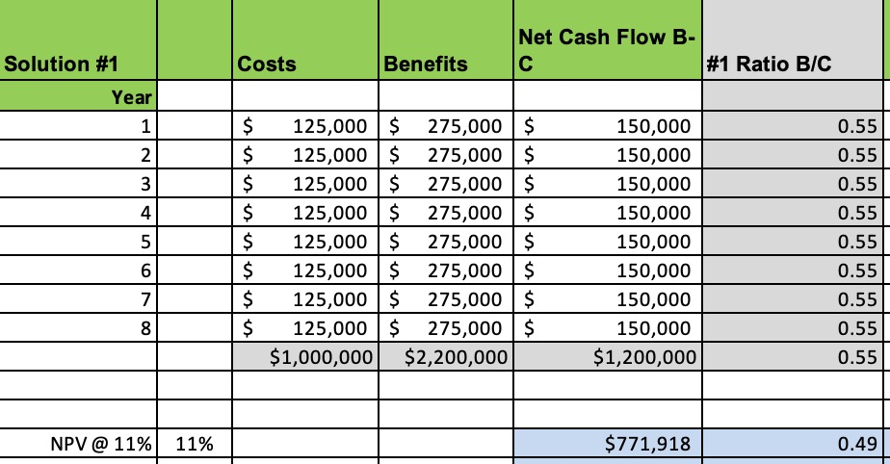

Figure 4. NPV of purchasing an entire new HRIS system that includes all the programming needed without purchasing additional software

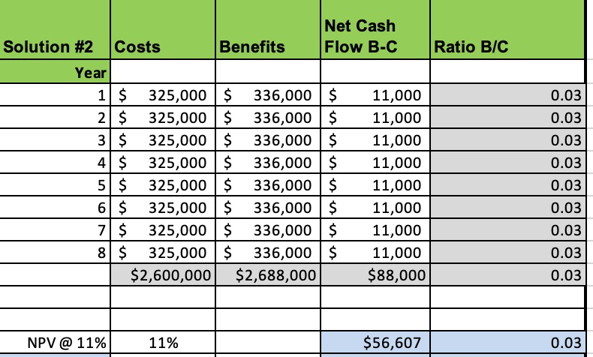

Payoff table/Decision Table
The second form of analysis is a payoff table/decision table. Using a payoff table will allow us to decide which alternative option is best to use. As shown on the decision table below, there is a combination of economic consequences or payoff for each decision. The payoff has a profit or a loss. The max profit represents an optimistic approach to the decision making because the alternative decision is evaluated to max profit under the most optimistic conditions. Results show that Solution C: purchasing additional programming will have a max profit of $390.00. While Solution A: Making no change and leave the program as is will have a min profit of $90.00. Overall, purchasing additional programming will give a loss monthly but after 30 cases per month, the max profit will be $390.00.

Figure 5. General Payoff Matrix
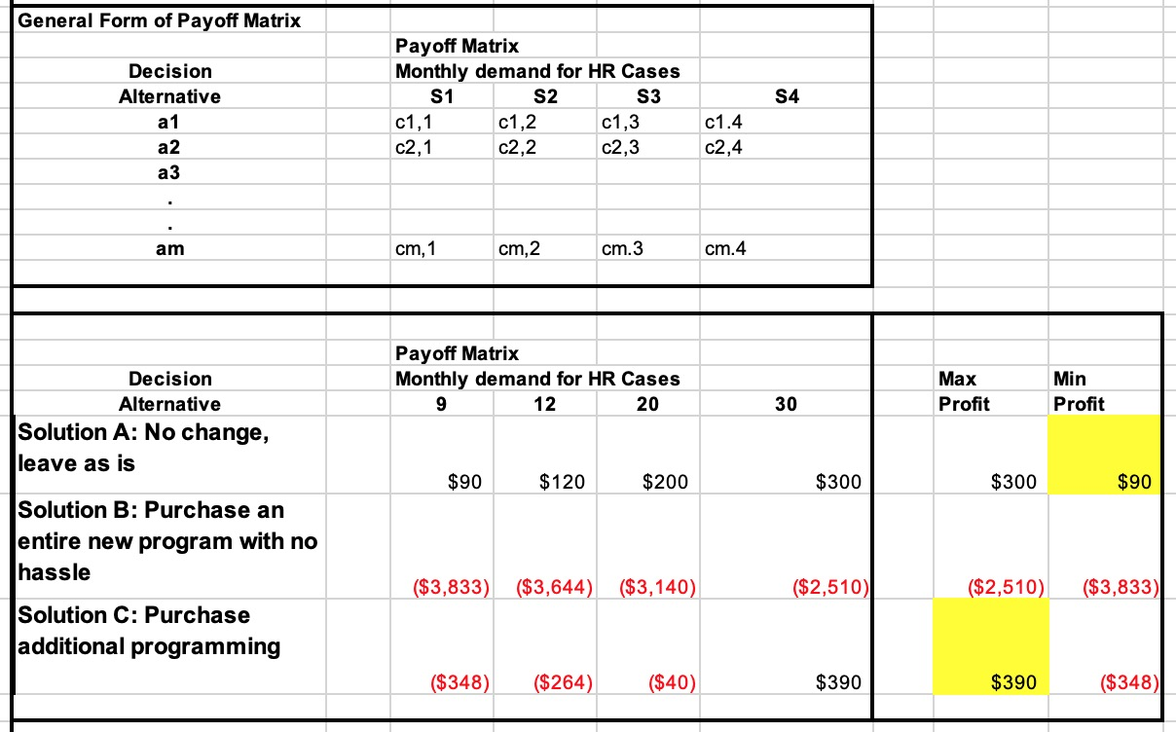

Run the Analysis

After assessing both analytical techniques for Solution 1 and Solution 2, it is recommended to go with Solution 1, which is to purchase additional programming and keep the existing software. Solution 2 had potential for success, however, due to time and cost it is out of range with reasonable budget and length of time to retrain an entire workforce. Meanwhile, by adding additional programming, it allows an opportunity for customization and accuracy for the users to utilize long-term and eliminates additional methods that waste productivity. The final recommendation to senior management is to change the entire process for utilizing case management and purchase additional programming to allow users to fully utilize the program in order to receive a return on investment and long-term reporting.

References

Leading HR Case Management Software. (n.d.). Retrieved May 10, 2019, from https://www.neocasesoftware.com/collaborative-case-management/
Major, D., Davis, D., Germano, L., Fletcher, T., Sanchez‐Hucles, J., Mann, J., . . . Lerouge,
Cynthia. (2007). Managing human resources in information technology: Best practices of high performing supervisors. Human Resource Management, 46(3), 411-427.
https://onlinelibrary.wiley.com/doi/epdf/10.1002/hrm.20171
Nagendra, & Deshpande. (2014). Human Resource Information Systems (HRIS) in HR Planning
and Development in Mid to Large Sized Organizations. Procedia - Social and Behavioral Sciences, 133(C), 61-67.27. https://reader.elsevier.com/reader/sd/pii/S1877042814030791?token=F8056B3735E5EE6808B6417AA67EA9FA088A1E7CEADCBB6AFCBBD3F9A27434578A55A1FD9AFEA84CB1DEA4DB7D4321A3

